Representation of gender violence in media
Television is one of the important and powerful media to influence people, shape their beliefs, knowledge, attitudes and behaviors and set stereotypes. People receive messages about gender issues by watching how and how often men and women are portrayed in television.
Majority of them aimed at analyzing the representation of women in media as passive, dependent and less efficient characters in the society as compared to men.
Women are increasingly shown being brutalised by men — slapped, beaten up, humiliated, abused — and, conversely, men are depicted as the exclusive decision-makers, who simply order the women in their lives around, telling them what to do or what not to do. What is extremely worrying about such scenes depicting male dominance, is that they invoke similar negative behaviour, especially among males in the general public. The ordinary man or woman becomes subject to this reinforcement of stereotypical images of women, and adapts and accepts these stereotypes as normal and natural.
Now a days we see a lot of news coming on domestic violence. Pakistan ranked as the sixth most dangerous country in the world for women with cases of sexual crimes and domestic violence.
Example:
Women that named asma aziz claims that she was attacked and humiliated by her husband because she had refused to dance for them.
And her husband shaved off her hair.
Fatima sohail wife of mohsin abbas haider, confronted him about his affair, he allegedly beat her, pulled her by her hair and threw her against the wall.
Every other drama uses the term ‘honour’ to exonerate criminals of the most heinous crimes. A brother’s or father’s reaction (even to the extent of committing murder, the so-called ‘honour killing’) when a sister/daughter is suspected of immorality, is portrayed in such a manner that the crime (the murder of the sister/daughter) is glorified and the victim condemned. Very rarely, almost never, do these serials convey the idea that ‘honour’ does not have a physical manifestation and is purely related to a person’s character. Honour can never be taken away by the use of force. If anyone’s honour is to be questioned, it should be the ‘honour’ of the perpetrator of the crime, not that of the victim (the woman).
Another disturbing aspect of many dramas is the overly negative emotions attached to having a daughter. Words and phrases constantly refer to the presence of a young daughter as a burden, a load that needs to be shed as soon as possible. The expressions of relief exhibited by an entire clan on getting a daughter married very strongly reinforce the age-old notion that ‘a woman’s real home is her susral (in-laws) and that a woman must have the protection of a husband to survive in this ‘cruel’ world.
Connected to this patriarchal approach is the issue of a divorced woman, or one in the process of getting a divorce. Reactions include sarcasm, taunting the woman and downright matam (mourning). The blame is placed squarely on the woman for not being able to keep her marriage intact or her husband happy. A woman who asks for a divorce is portrayed as committing an unpardonable act. A man can say talaq three times to his wife for no reason with impunity, but a woman wanting to get out of an abusive or difficult relationship is still made to look socially unacceptable.

Media violence
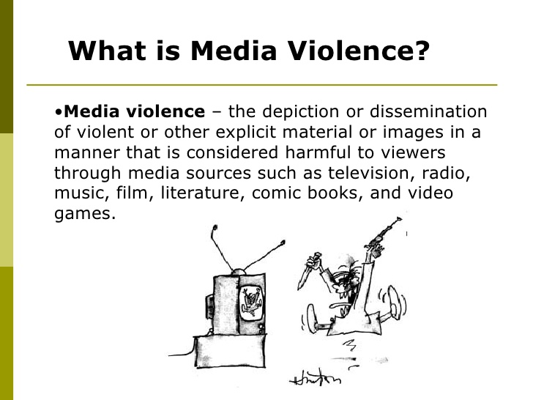
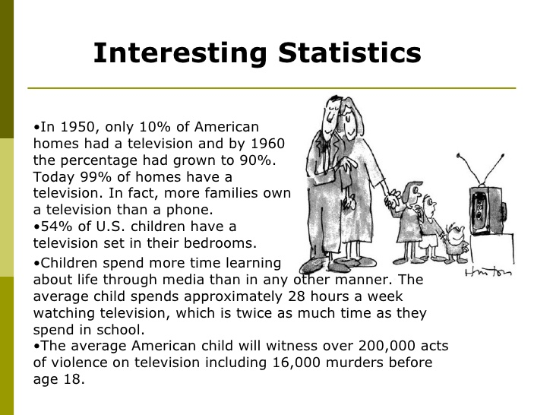
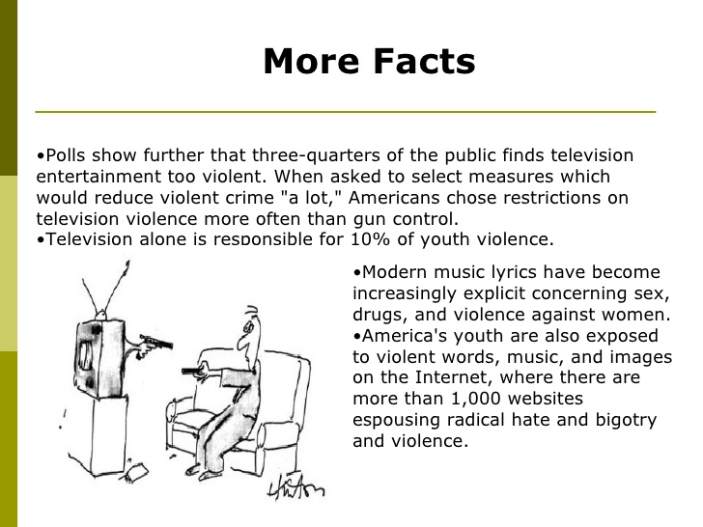
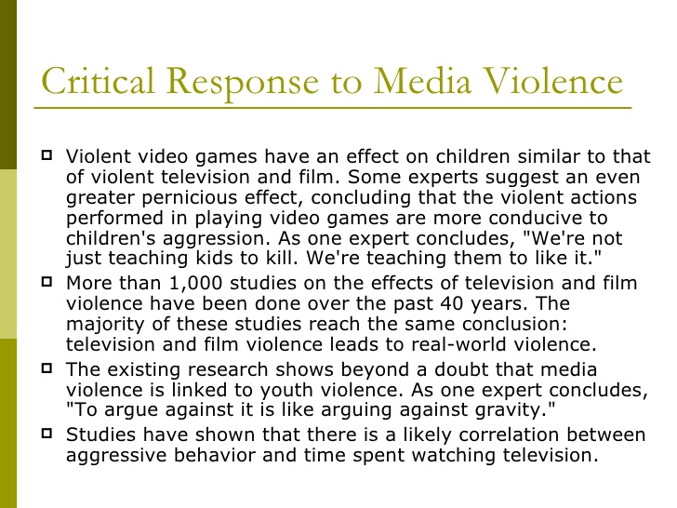
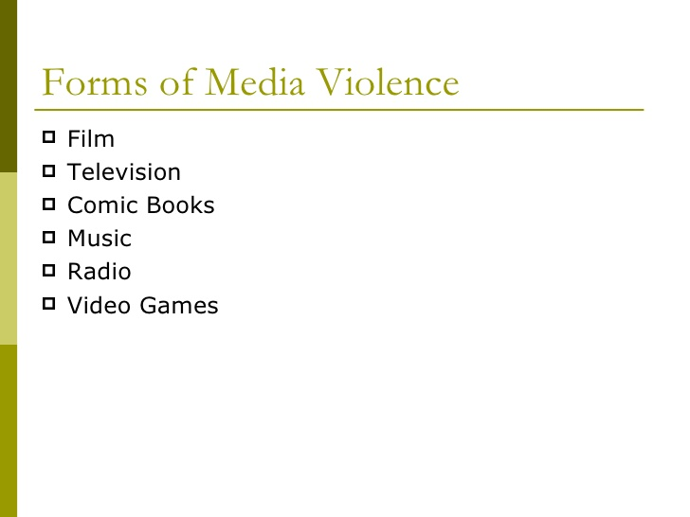
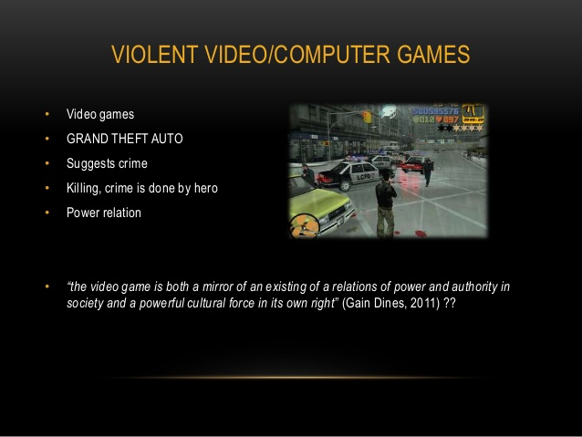
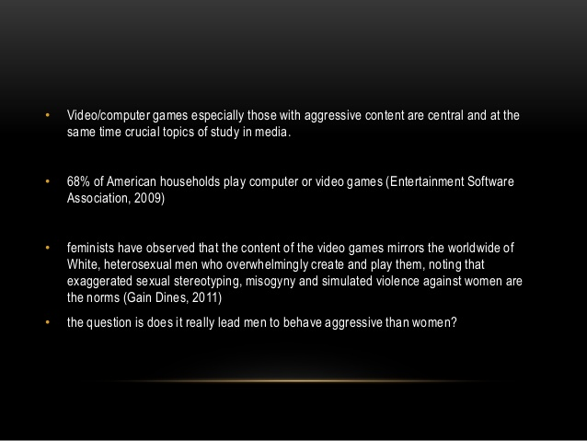
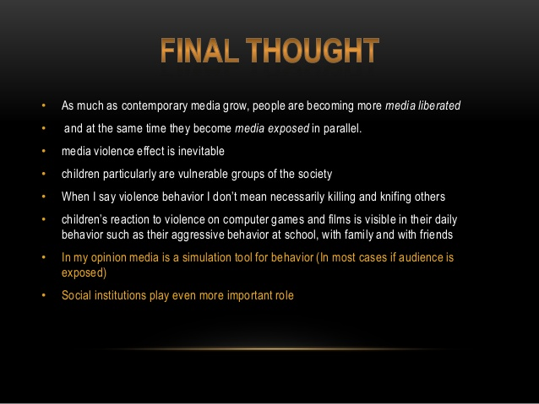

Media violence poses a threat to public health inasmuch as it leads to an increase in real-world violence and aggression.
Research shows that fictional television and film violence contribute to both a short-term and a long-term increase in aggression and violence in young viewers. Television news violence also contributes to increased violence, principally in the form of imitative suicides and acts of aggression. Video games are clearly capable of producing an increase in aggression and violence in the short term, although no long-term longitudinal studies capable of demonstrating long-term effects have been conducted. The relationship between media violence and real-world violence and aggression is moderated by the nature of the media content and characteristics of and social influences on the individual exposed to that content. Still, the average overall size of the effect is large enough to place it in the category of known threats to public health. Exposure to violence in media, including television, movies, music, and video games, represents a significant risk to the health of children and adolescents. Extensive research evidence indicates that media violence can contribute to aggressive behavior, desensitization to violence, nightmares, and fear of being harmed.

